

Heat Related Illness

A Hot Topic



June 1, 2025

AMT

Instructions

Read the article (really, read the whole thing)

Take the test (the QR code for the test is on the last page)

Receive one hour of continuing education

Heat Related Illness:

OBJECTIVES – On completion of this course the student will be able to:

1. Understand how the body regulates its temperature to maintain homeostasis.
2. Define heat related illness.
3. List specific populations that are at higher risk for heat-related illness.
4. Identify medications that can contribute to heat related illness.
5. Understand the causes, signs, and symptoms of and treatment for:
   1. Heat cramps, exercise associated muscle cramps.
   2. Heat exhaustion.
   3. Heat stroke. Exertional heat stroke.
6. Understand the role of EMS and rehabilitation on the fire ground.

A HOT TOPIC

**Homeostasis and Thermoregulation**

Through homeostasis, the human body attempts to keep an internal environment between 35.6°C to 37.8°C. The hypothalamus acts as the body's thermostat and through a negative feedback loop, maintains this balance. If the body's temperature drops below 35.6°C, the heat promoting center in the hypothalamus is activated, blood vessels near the surface of the skin constrict, and blood is kept away from the surface of the skin, allowing it to maintain its warmth. If even more heat is needed, skeletal muscles start to shiver and heat is produced. When the body temperature rises to more than 37.8°C, the heat loss center of the hypothalamus is activated. When this happens, blood vessels near the surface of the skin dilate and the capillaries near the surface are able to offload heat. To aid in this process, sweat glands are activated and we begin to perspire, the perspiration Evaporates and aids in cooling the body. Hopefully this allows the body to cool and homeostasis to be maintained. At times because of high ambient temperatures or extreme physical exertion, the body is never able to return to homeostasis. When this happens when he may be presented with heat-related emergencies.

**Heat-Related Illness**

Heat related illnesses include heat cramps, heat exhaustion and heat stroke. These are usually the result of exposure to extreme heat. In the worst case presentation, the normal physiological action of the body is unable to cool itself. This results is a rapid rise in core body temperature (CBT). One of the main ways the human body cools itself is through perspiration. This convection or evaporation of sweat helps to cool the body. When the humidity is high, sweat does not evaporate as quickly. This prevents the body from cooling efficiently each year, at least 685 people die from heat related illness. Virtually all these deaths are preventable. Prompt treatment of heat related illness with aggressive fluid replacement and cooling the core body temperature (CBT) is critical to reducing illness and preventing death. Health related illness can be seen as a continuum progressing from heat cramps to heat stroke. However, as prehospital clinicians, we may not encounter a patient until they have progressed to the most severe form, heat stroke.

**Highest temperature**.

The highest temperature ever recorded in a human being was in 1980, when Willie Jones suffered heat stroke and survived a temperature of 115.7°F.

Multiple factors increase an individual's chance of experiencing a heat-related illness. Environmental factors such as high ambient temperatures and high humidity 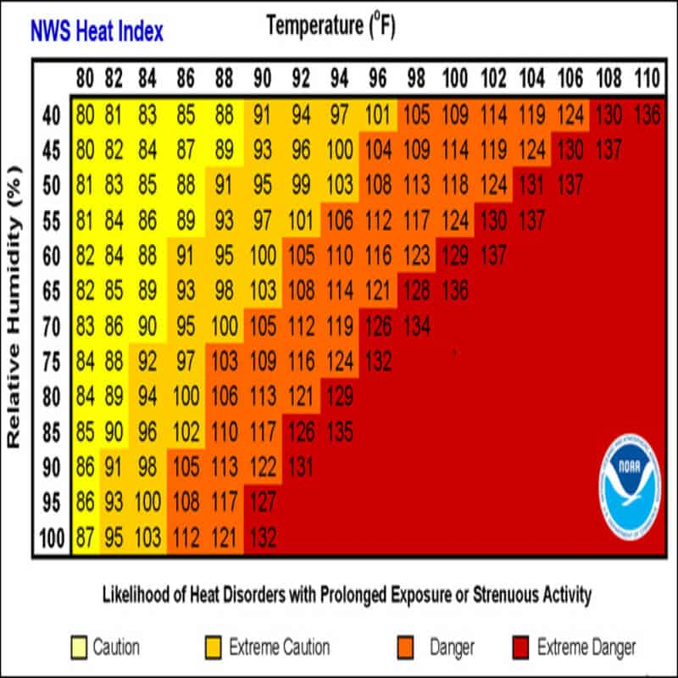 place an individual at a much higher risk. Heat related illness can be broken down into three major categories: Heat cramps, heat exhaustion, and heat stroke. Patients who are obese, dehydrated, take certain medications and abuse alcohol also have a heightened risk of succumbing to heat related illness. Our geriatric and pediatric populations are at a higher risk for heat cramps, heat exhaustion, and heat stroke, but even younger, healthy people can be affected, especially when they're engaging in strenuous physical activity.

**Heat Cramps**

Heat cramps are the cramping of skeletal muscles that result from excessive sweating. The excessive sweating causes a decrease in the level of sodium and to a lesser extent, magnesium and potassium in the body. Heat cramps are most often seen in younger, otherwise healthy individuals who are performing strenuous activities in a hot environment, with a heat index of greater than 100°F. Not being acclimated to environment is another contributing factor to heat cramps.

Exertion-associated muscle cramps (EAMC) have a very rapid onset and are defined as a prolonged muscle spasm that is often associated with a hot, humid environment. Generally the extremities are affected first. At times, hands and feet may have debilitating spasms. Muscles in the arms and particularly the legs will feel hard and knotted. Vital signs will be normal with normal body core temperature. Depending on the climate, the patient skin may be either hot and dry or cool and clammy.

Treatment for EAMC begins with moving the patient to a cooler environment. Rehydration with electrolyte containing sport drink will help replace the loss sodium. Research suggests that cooling the cramping muscles with ice packs or towels soaked in ice water can be helpful. Unless protocol specifically called for it. Patients should not be given salt tablets. Salt tablets can cause stomach irritation and a high dose can lead to edema. Patients presenting with EAMC generally do not require any further treatment or transport unless the cramping is so severe that they are unable to hydrate orally. Should the patient be unable to hydrate orally, ALS may be needed. Treatment should include intravenous access and infusion of up to two liters of normal saline. Any patient that requires IV fluids should be placed on the cardiac monitor and closely monitored for dysrhythmias. Severe cramping may be a warning sign of heat exhaustion.

Medications that can contribute to heat-related Illness

Antihistamines Beta Blockers Diuretics Benzodiazepines

Diuretics Calcium Channel Blockers Tricyclic Antidepressants

**Heat Exhaustion**

Heat exhaustion is a less severe form of heat-illness. Patients experiencing heat exhaustion may often present with vague signs and symptoms. In heat exhaustion, the patient will present normothermic or only a slightly elevated CBT. Less than 102.0°F. They will be perspiring and present with a normal level of consciousness, although they may be anxious or mildly confused. They may be hypotensive and tachycardic. Other symptoms may include dizziness, weakness, headache and nausea.

The single most important treatment for patients presenting with heat exhaustion is removal from the hot environment. Simply moving the patient out of direct sunlight into a shaded area can equal to a 10°F to 15°F decrease in the ambient temperature. Remove any excessive clothing and if the patient is able, begin oral dehydration. Research notes that drinking water is better than no hydration, but the biggest benefit will be gained by drinking a carbohydrate electrolyte sports type drink. If the patient is unable to tolerate oral rehydration secondary to nausea or vomiting, ALS intervention should be considered. An IV should be established and normal saline should be infused per local protocols. The patient should be placed on the cardiac monitor and watched closely for any dysrhythmias. If the patient's symptoms do not resolve within 20 to 30 minutes, transport for further evaluation and treatment should be considered.

**Classic Heat Stroke / Exertional Heat Stroke**

Heat stroke has two major presentations, classic heat stroke that generally affects either pediatric or geriatric patients during times of high heat and exertional heat stroke that affects younger, generally healthy individuals that are at work or play in high ambient temperatures. Think of firefighters operating at a structure fire or construction workers on an extremely hot day.

The stereotypical victim of classic heat stroke is a geriatric patient who lives in a large city and has limited or no access to air conditioning. In 2012, during a 10-day period of 100°F temperatures, 7 people died in Saint Louis. Six of them were aged 62 or older, the 7th was an 8-year-old. During a heat wave that struck St. Louis in July of 1966, prior to ready access of air conditioning, 246 people died of heat related illness. 192 of them were older than 60 years of age. During heat waves, many cities have designated cooling centers opened as a proactive approach to treating heat related emergencies. The treatment for classical heat stroke is the same as for exertional heat stroke and will be discussed at the end of this topic.

Exertional heat stroke (ETHS). Is generally the result of physical exertion in a very hot and humid environment for extended periods of time. ETHS, when left untreated, can be fatal. Goforth and Kazman (2015) report an 18% mortality rate in military personnel who are not treated with evidence-based guidelines. The hallmark of ETHS is an elevated core temperature, usually greater than 40°C (104°F) that is associated with signs of organ system failure due to hyperthermia. Often the first signs of heat stroke are changes in mentation such as delirium, confusion, and agitation. The heat stroke patient may have dizziness or be lightheaded. They will probably be nauseated and vomiting, which will preclude the ability to orally hydrate. The patient may present with classic stroke symptoms such as slurred speech and ataxia. The body's ability to maintain homeostasis has failed and the patient may present with anhidrosis.

ETHS can have a very rapid onset and there may or may not be symptoms of heat exhaustion prior to the onset of EHS. Goforth and Kazman (2015) explain how one factor that can lead to EHS are highly motivated individuals such as military personnel, athletes, or firefighters. These individuals are so motivated on completing a mission that they failed to heed the warnings of impending ETHS.

The single most important goal in the treatment of heat stroke is the reversal of hyperthermia and lowering the patient's CBT. Goforth and Kazman (2015) state that the immediate cooling to the patient is more important than transport. Glacier (2005) suggests that one of the best ways to lower CBT is to have a mist of cool water sprayed on the patient and fans to aid in evaporation. This method has been shown to lower CBT by as much as 0.5°F per minute. Goforth and Kazman (2015) argue that the fastest and most effective way to lower the CBT of a patient with suspected heat stroke is by immersion of the extremities and trunk in cold water. To achieve best results the water has to be very cold, 36°F to 46°F. But even cool water will work, the patient immersed in water that is 68°F is expected to have a 0.3°F drop in temperature per minute. The goal of cooling is to bring the patient’s core. Temperature to less than 102°F.

At the ALS level, an IV should be established in normal saline, administered per local protocols. The patient must be placed on the cardiac monitor and very closely assessed for possible dysrhythmias.

**The Role of EMS in Preventing & Treating Heat-Related Illness on the Fireground**

It was noted that one category of individuals that are at higher risk for heat related illness are highly motivated individuals. One place EMS will frequently encounter this is on the scene of a structure or wildland fire. Many EMS agencies have found themselves tasked with providing rehabilitation for firefighters at structure fires, wildland fires, and hazardous materials incidents. We are fortunate to have guidance on the best practices for caring for firefighters that may be heat stressed. NFPA. 1548. 2015 Edition Standard on the rehabilitation process for members during emergency operation and training exercises offers best practices on the rehabilitation of firefighters at scenes that are likely to increase the risk of heat related illness.

The best and only truly reliable method of determining a core temperature is by a rectal thermometer. Since this is very impractical on the fireground, we will have to consider the risk of heat-related illness by other means. One important factor is the ambient temperature. When there is a large gradient between a firefighter's core temperature and the ambient temperature, it is not difficult for the firefighter to quickly cool down when the ambient temperature is high and the heat gradient is low, it can be much more difficult for the firefighter to cool down efficiently. Another important factor is the heat index. On hot days, a high relative humidity can quickly push firefighters in full turnout gear well into the extreme danger range. They will require active cooling once they have entered rehab. When the heat index suggests conditions that call for caution or even extreme caution, firefighters should be sent to the rehabilitation per preset protocols. Often after the use of one air pack.

At the very minimum, the firefighter should remove all protective gear and be passively cooled. This includes sitting in a shaded area with fans running at the firefighter. If the firefighter presents with any indications of even mild heat exhaustion, such as profuse sweating, lightheaded, or weakness more active cooling should be initiated. This includes cool mist, wet towels, ice vests, and the use of forearm immersion. The use of forearm immersion has proven both effective And. practical in the fireground setting. House Holmes and Allsopp (1977) explained how immersing the forearms and hands in cool water can bring down the CBT dramatically in only 20 minutes.

**Should sports drinks be diluted?**

Many EMS providers will dilute sports drinks with the thought that this will reduce nausea. Bledsoe (2011) suggests that is not a good practice, since the manufacturers of the drinks have formulated their drinks to be consumed as is and it may even slow down the absorption of the all important electrolytes and carbohydrates.

The other key component to rehabilitation and combating heat related illness on the fireground is rehydration. Fluid loss through perspiration is an important mechanism to combat heat related illness, but for this to work, the firefighter must be hydrated. As previously noted, drinking water is better than no oral hydration. But the biggest benefit will be gained by drinking a carbohydrate, electrolytes sports type drink.

ANHIDROSIS – The lack of sweat production in response to thermal stimuli, often related to thrmoregulatory control ofrom the central nervous system.

ACCLIMATION – The process or result of becoming accustomed to a new climate or new conditions.

COOLING ACTIVE – The process of using hand or forearm immersion, misting fans or ice vest to reduce elevated core temperature (Per NFPA 1584).

COOLING PASSIVE – The process of using natural evaporative cooling, such as sweating, doffing PPE and moving to a cooler environment to reduce elevated core temperatures (Per NFPA 1584)

HOEOSTASIS – The tendency of the human body to maintain internal stability, owing to the coordinated response of its parts to any situation or stimulus that would tend to disturb its normal condition

Glossery

**Conclusion**

As EMS providers we will be called upon to care for patients who have been overcome by heat. It may be on a sports field, fireground or the apartment of an elderly patient. It will be difficult for us to obtain an accurate CBT. So we must base our treatment on our assessment of the patient. In its worst form heat related illness can be fatal if left untreated, but with the proper assessment and treatment, the mortality rates drop to virtually zero.

When you have completed reading the article, please take the online quiz and sign the attached sign-in sheet. The QR code is below.

